**5. How to Use the System**

1. **Login Page**

Here, the user needs to insert their username and password in order to login. Then, the user would need to click on the button “Submit to enter the page”.

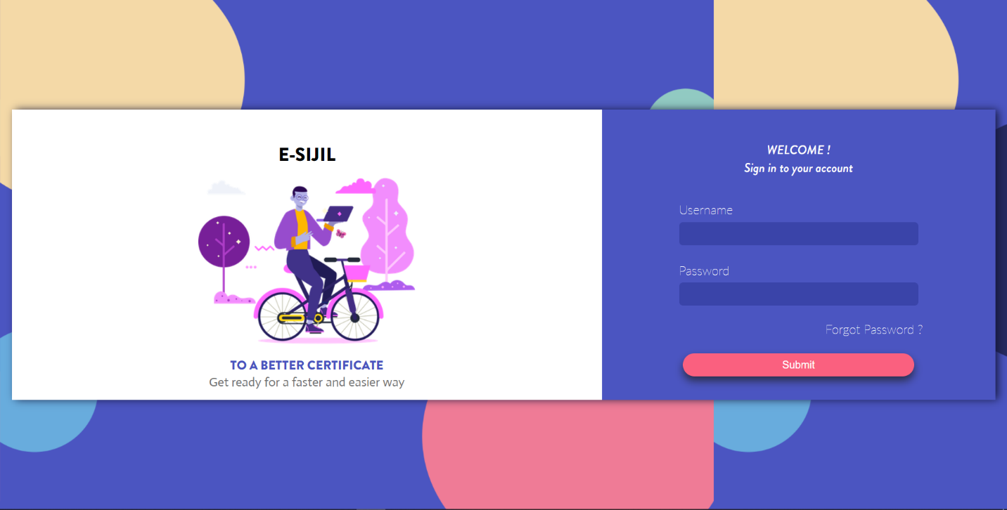

1. **Home Page**

This page shows the details of the team members. On the left side is a navigation bar. User would navigate using that bar by clicking on the page they wished for. To log out, click on “Logout” in the sidebar.

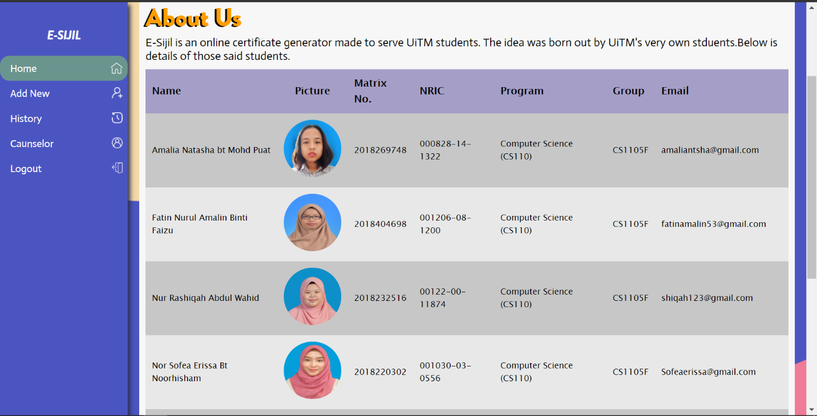

1. **Add New Certificate**

This page shows the interface if the user clicked on “Add New” located at the sidebar. The user would need to fill in the form to generate a new certificate and then click on “Generate !” button once done.

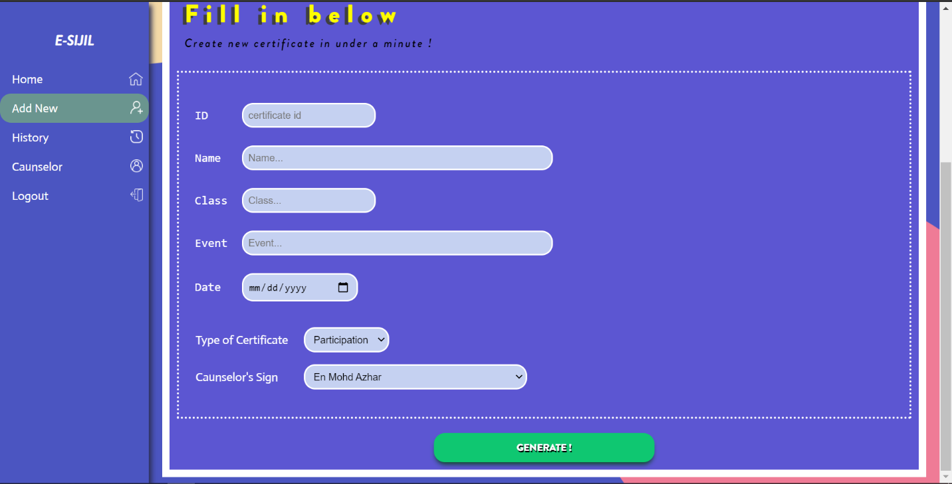

Once the certificate is successfully generated, a message of confirmation will pop up.

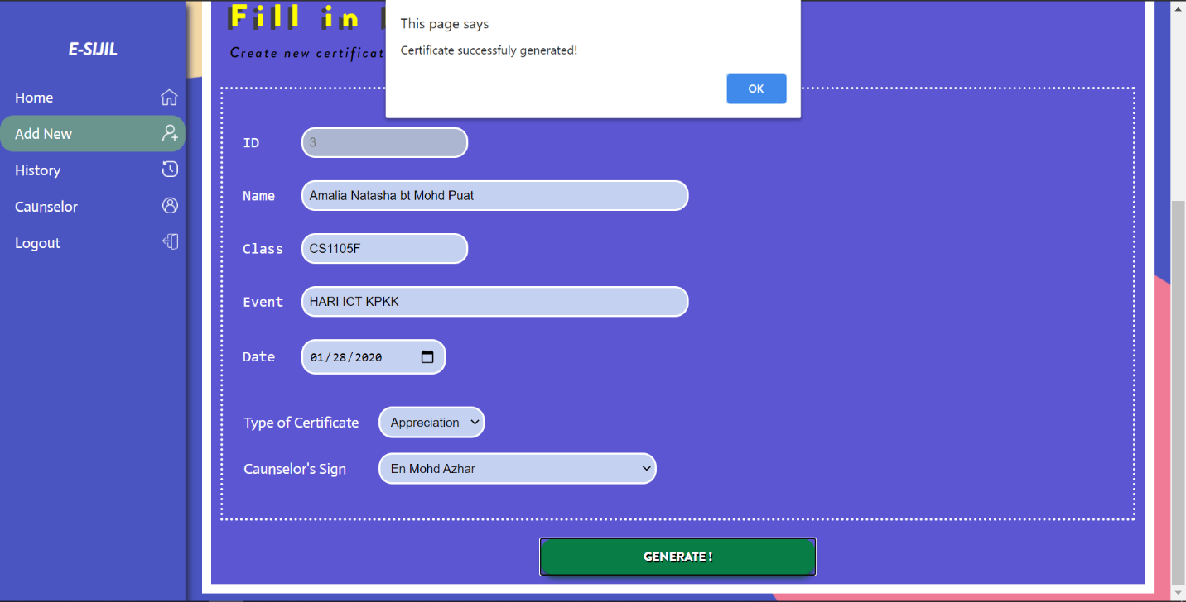

This is the generated certificate. To print the certificate, the user would click on the button “PRINT” to print the certificate.

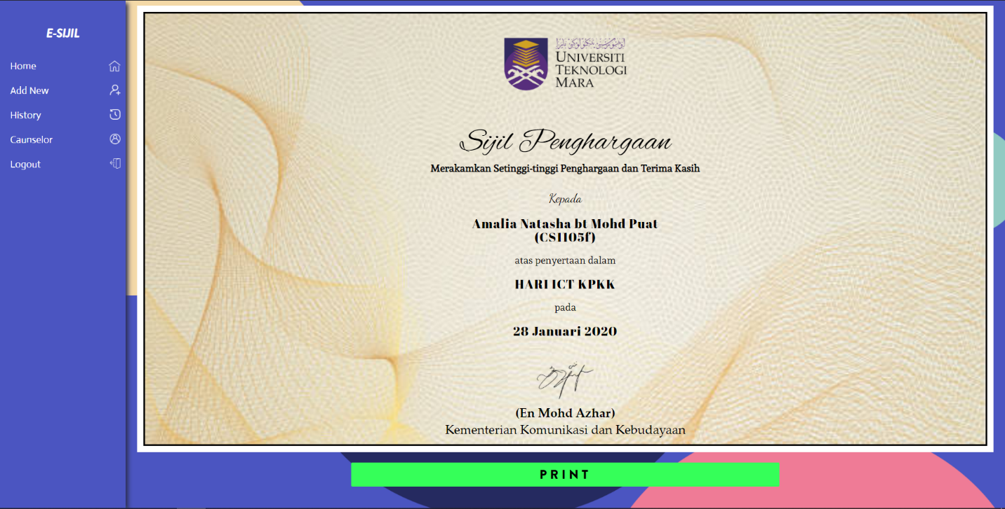

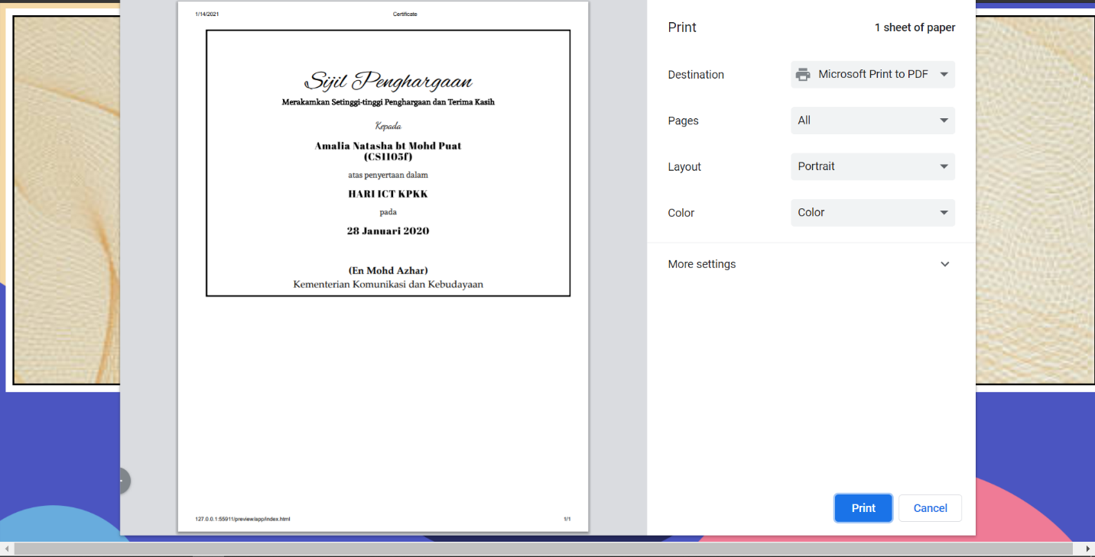

1. **History**

To view history of past generated certificates, click on “History” located at the sidebar. In this page, user would be able to update and delete by clicking “Update” or “Delete” button in the row they wished to perform that actions..

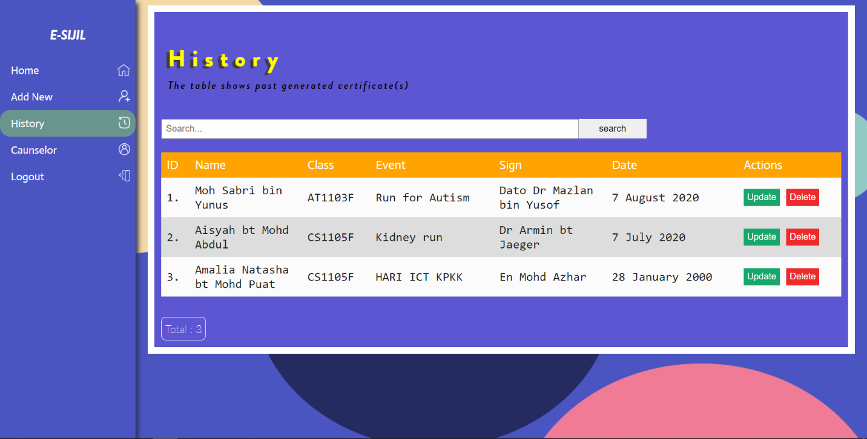

To view the certificate, click on the row of said certificate.

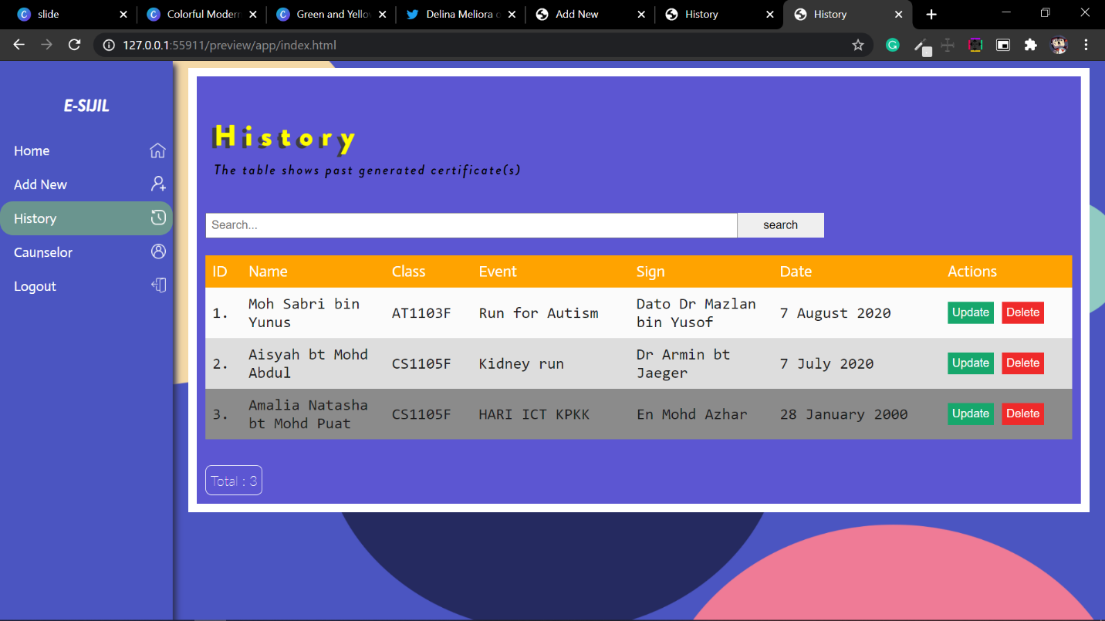

The system would show the certificate of the row clicked.

To search, fill in the search bar with any details of the said person and then click on the “Search” button.

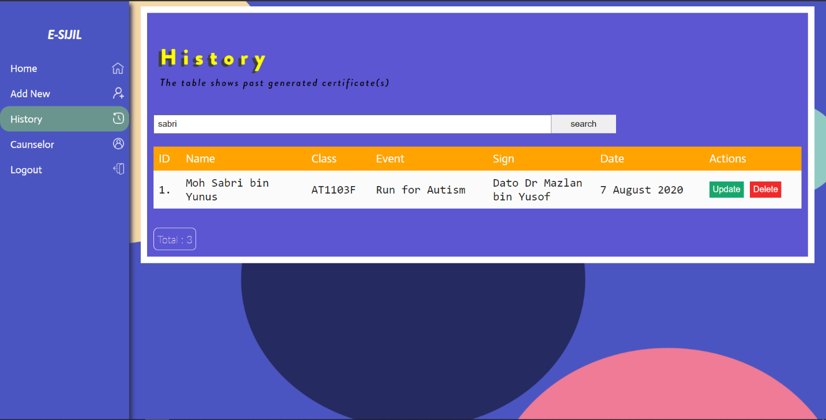

Once “Update” button is clicked, the system would present a form. Update any information by filling in any input box. Once done, click on the “Update” button. The picture below shows that the user changing the class name from CS1105F to CS1104F.

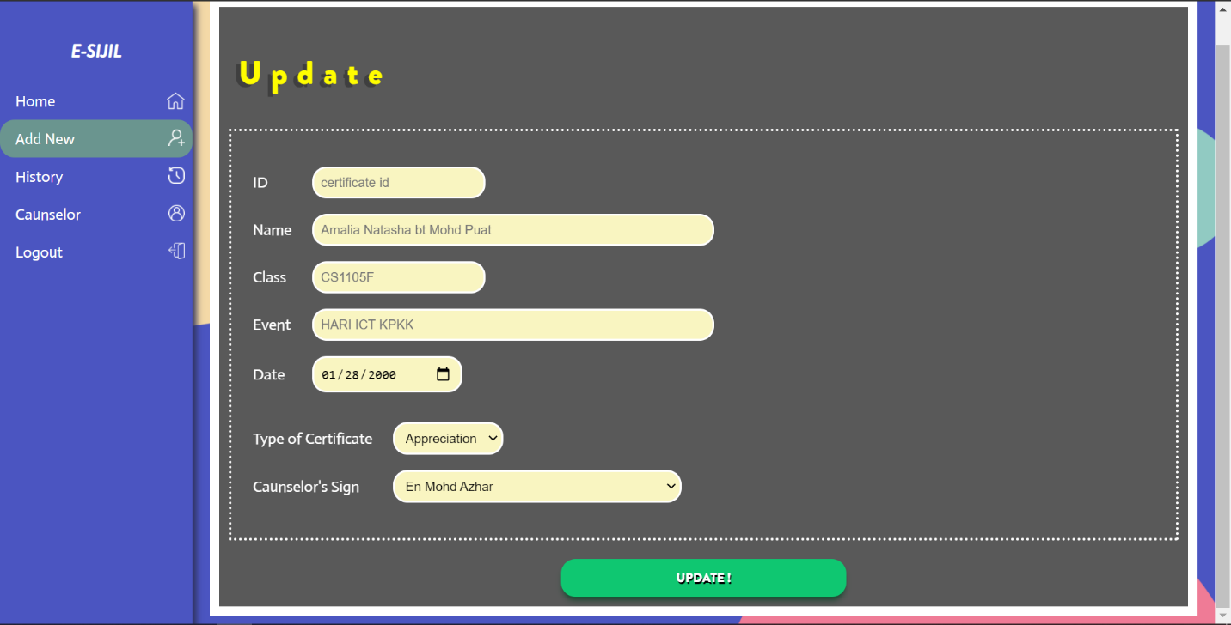

If the system updated the information successfully, a message would pop-up to notify the process.

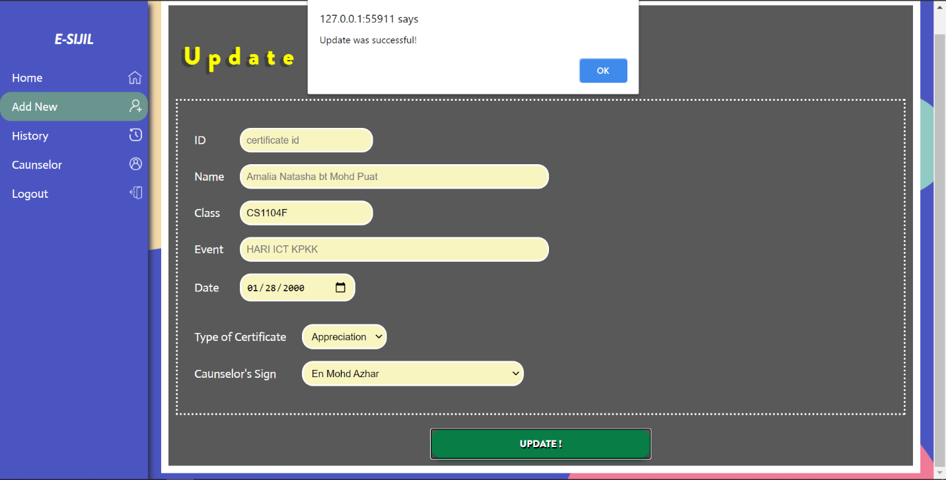

The updated information would be displayed on the same page.

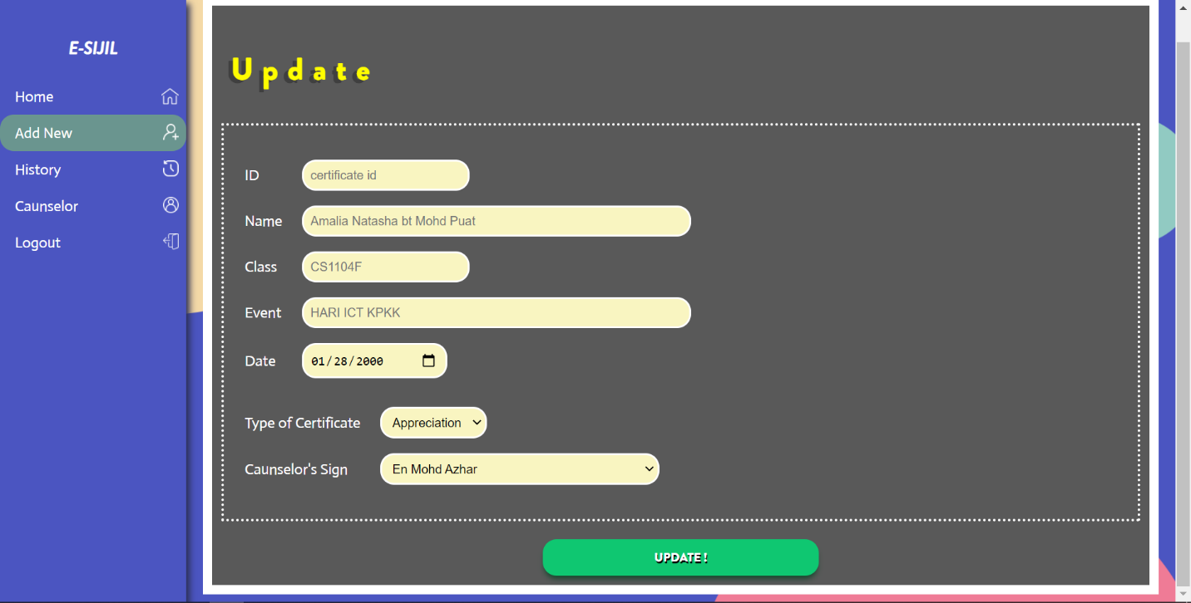

If “Delete” button is clicked, a question would pop-up to gain confirmation of that action. Click on “Ok” if the user still wish to perform deletion or click on “Cancel” if otherwise.

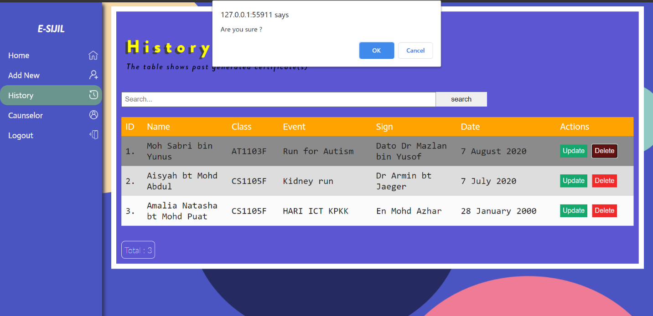

If the process went successful, a message would pop-up to notify.

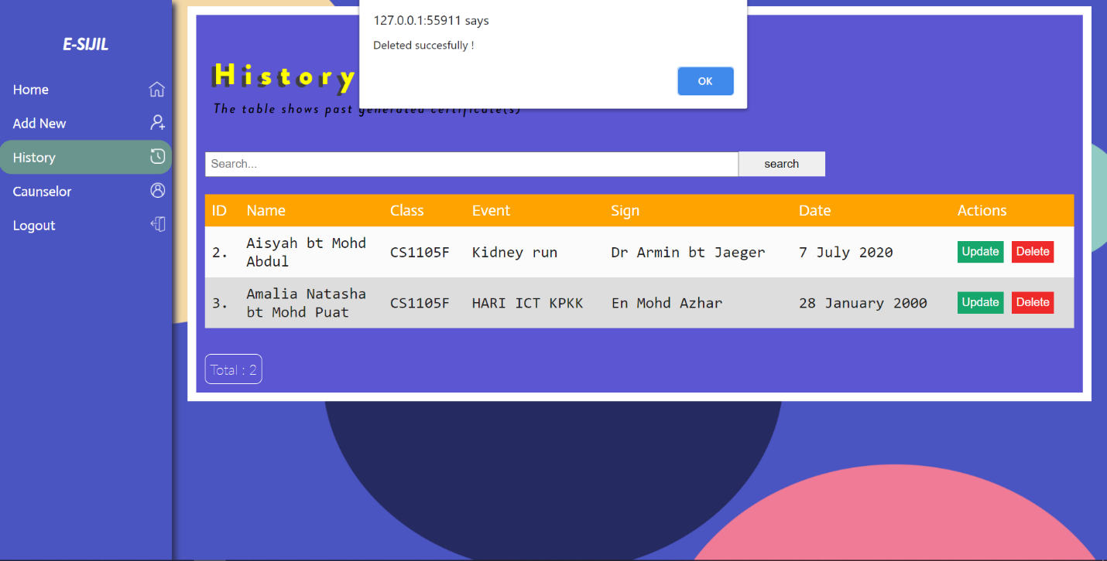

1. **Counselor**

To see counselor details, click on “counselor” in the sidebar. In this page, user would be able to update and delete by clicking “Update” or “Delete” button in the row they wished to perform that actions. To add a new person, click on the green button with a person and a plus sign logo.

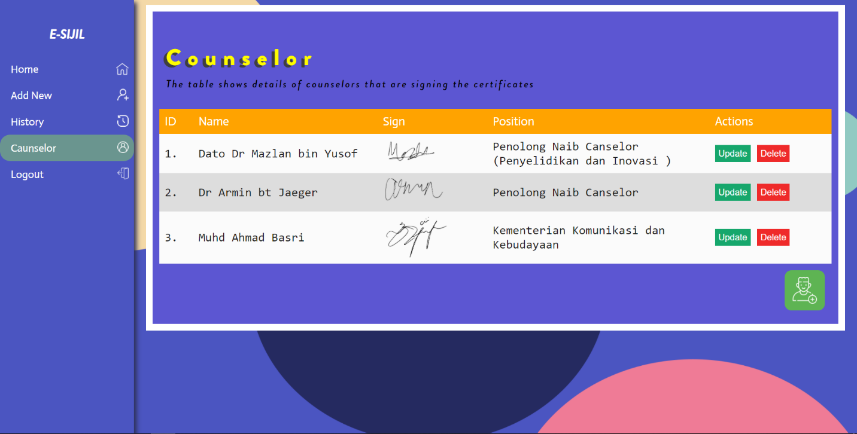

If the “Update” button is clicked, the page would output a form. User would need to fill the in part they wished to update, then click on “Update !” button once done.

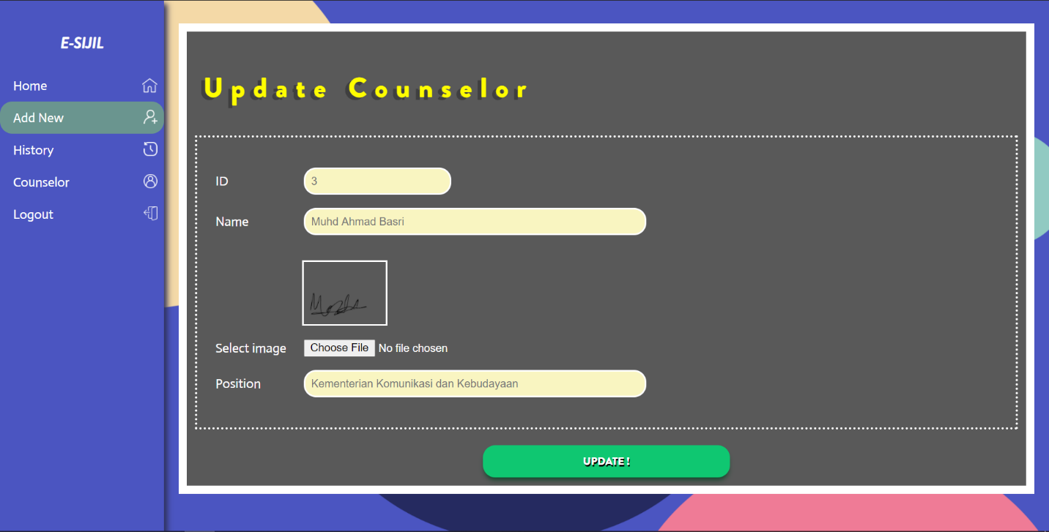

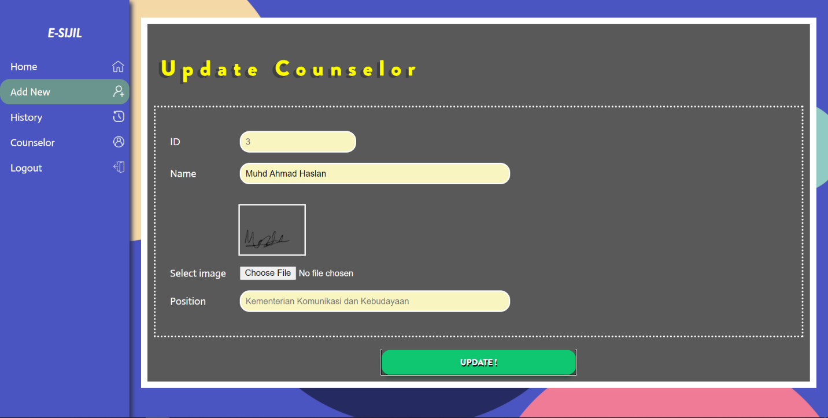 Picture below shows that the user is updating the counselor’s name.

Once done, a message will pop-up if the update process went successful.

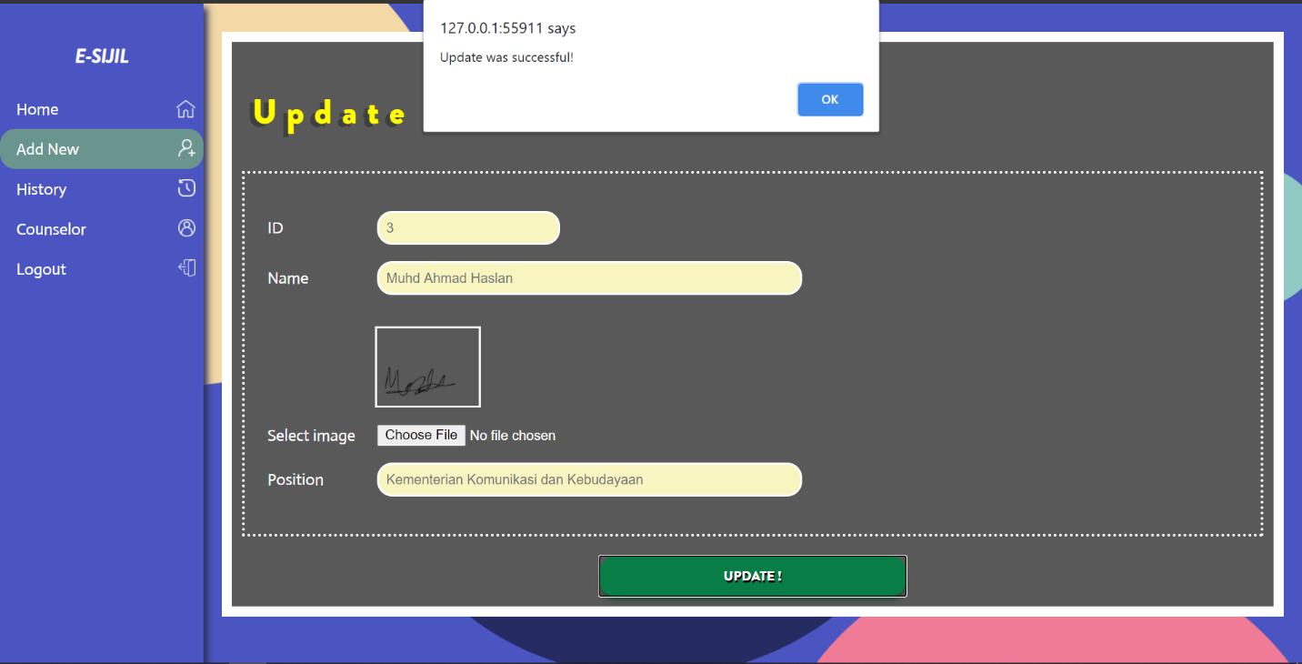

If the green button with a person and a plus sign logo is clicked, the system would display a form. Fill in the form with the person’s details and click on “Add !” button once satisfied.

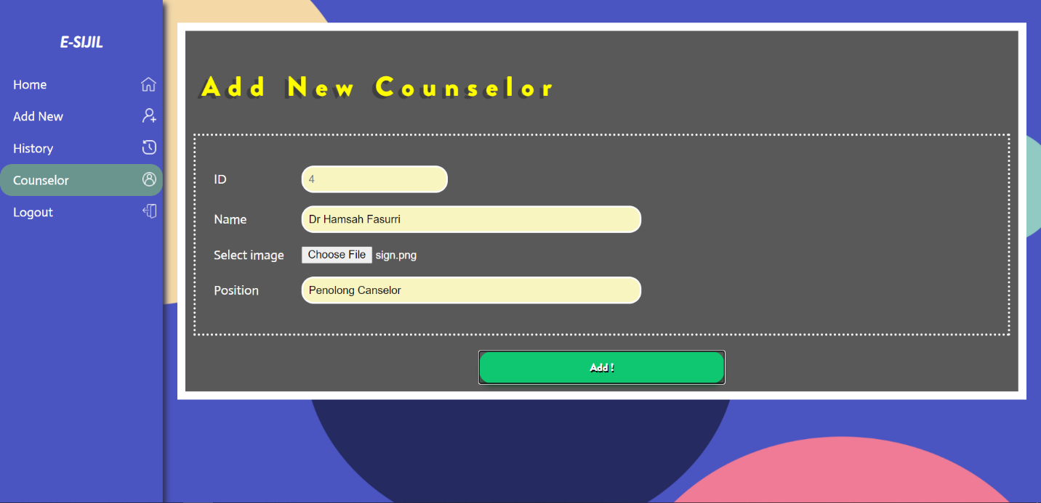

If the person details were successfully added to the database, a message would pop-up to inform it. The information would be displayed on the table.

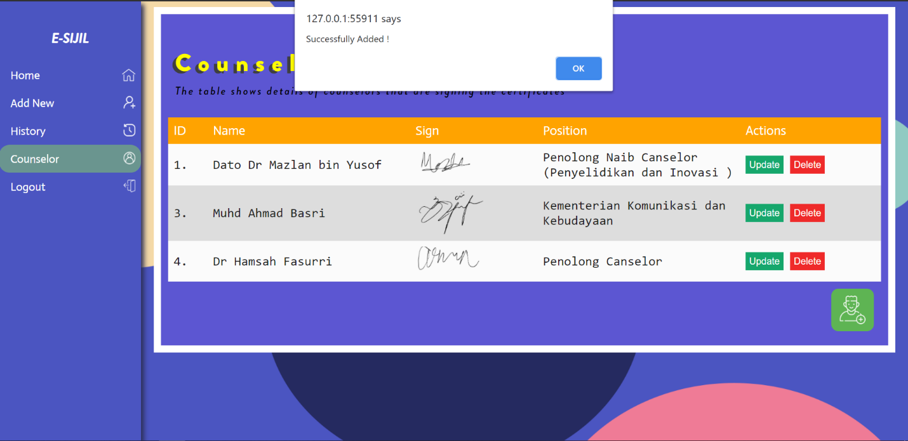

If “Delete” button is clicked, a question would pop-up to gain confirmation of that action. Click on “Ok” if the user still wish to perform deletion or click on “Cancel” if otherwise

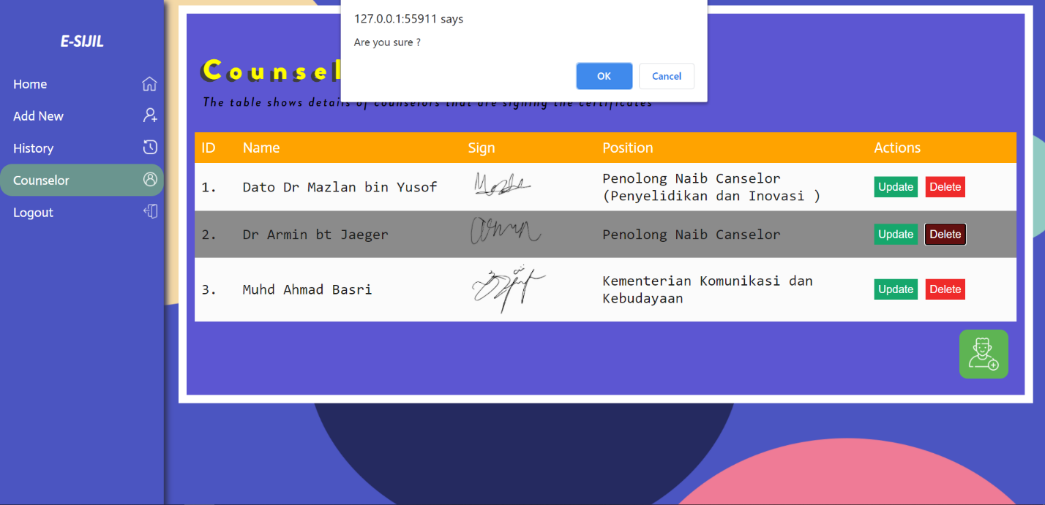

If the process went successful, a message would pop-up to notify.

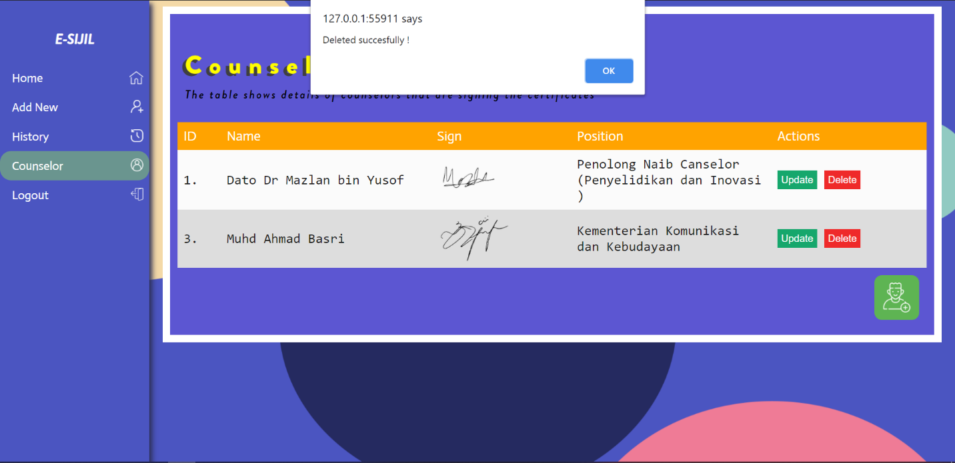

1. **Output Sample**

Picture below shows output of a generated certificate

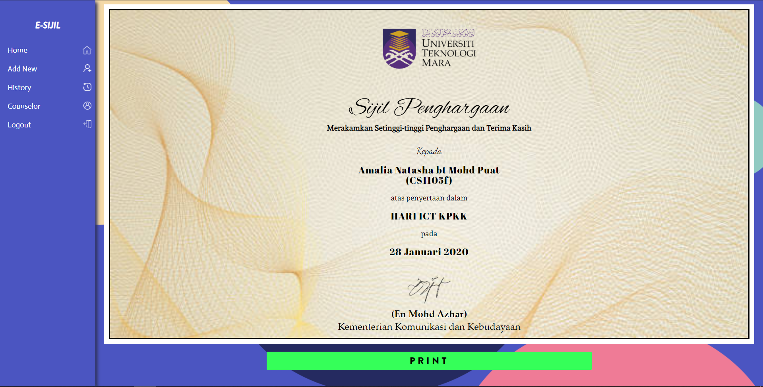

If “PRINT” button is clicked, the system would output only the necessary part and it is ready to be printed.

